Antelope Valley Indian Museum
Nature Trail

The self-guided nature trail that starts in the museum parking lot is an easy half-mile walk that takes about 30 minutes to complete. It will introduce you to American Indian people of the area and some of the animals, plants, and natural features that were important to them.
There are 14 posts along the trail. The numbers in this guide correspond with the numbers on each post.
Please protect the environment:
- All animals, plants, and rocks within the State Park are protected by law and are not to be removed or disturbed.
- Dogs are not permitted on the trail.
- Please stay on the trail at all times. Certain local snakes are poisonous. If you encounter a snake on your walk, simply stop and let it go its own way.
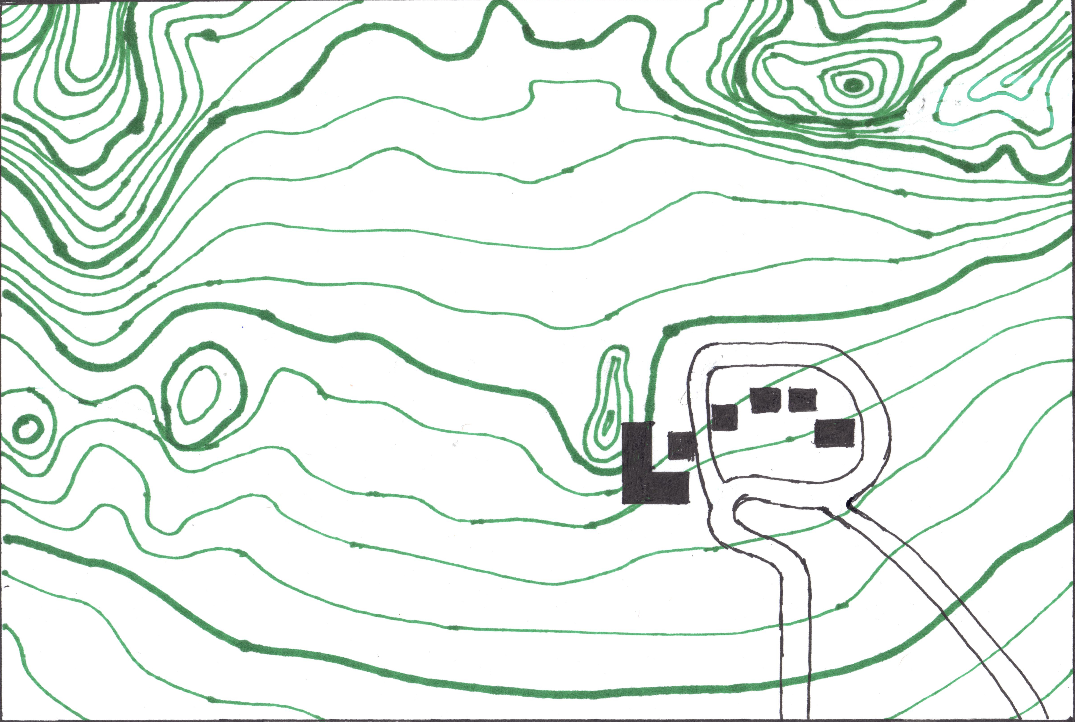
1. People of the Antelope Valley
During the past one thousand years or more, the Antelope Valley was inhabited or frequented by several American Indian groups including the Serrano, Kitanemuk, Tataviam, and Kawaiisu. They had a unique relationship with their environment. In addition to the wide variety of plant and animal resources available in the Antelope Valley, easy access from all directions and numerous flowing springs made the valley an ideal corridor for trade among many different groups of American Indians. Goods from throughout the American Southwest and California found their way here.
2. San Gabriel Mountains
The high peaks that you see on the southern horizon are the San Gabriel Mountains. Both the foothills and the higher slopes of this range provided varied food resources, such acorns and pinyon pine nuts.
3. Ground Squirrels
As you look around this area, you may spot an antelope ground squirrel as it scurries about searching for seeds. This small creature (which resembles a chipmunk) is one of the few desert mammals active during the daytime. Even if you don’t see any animals, you may notice openings to underground burrows located near the bases of plants. Although small, the native people of the Antelope Valley made use of rodents such as the antelope ground squirrel for food.
4. Barn
At this point as you look toward the north, you will see an old barn and corral, which were built by Howard Arden Edwards, the founder of the museum, in 1932. Originally, they were located east of the museum, but the museum’s second owner, Grace Oliver, moved them here. The barn and corral are historic structures, so we ask our visitors to help us in our preservation efforts by avoiding them.
5. Rabbits
As you walk along the trail, you may be startled by a jackrabbit or cottontail as it darts rapidly from beneath a bush. Although these two creatures have certain similarities, they are actually separate species. The jackrabbit is a hare while the cottontail is a true rabbit. Rabbits were the most common animals the American Indians hunted for food in the Antelope Valley. People used the skins to make rabbit skin blankets that they wore in cold weather and at night. Each blanket required 100 rabbit skins.
If you listen, you might hear coyotes yelping up on the butte. Coyotes often visit the museum, but they are shy and stay up in the rocks if there are people around. Coyote plays a role in many of the stories the native people of the Antelope Valley.
6. Grinding Rocks
Flat rock outcroppings (called “bedrock”) were often used by the native people of the Antelope Valley as grinding surfaces for crushing and pulverizing seeds and nuts into flour. Over long periods of time, the pounding and grinding action leaves polished areas on the surface, called grinding slicks, or deeper depressions, which are known as bedrock mortars. A handstone (or “mano”) used for grinding was found near this very boulder.
7. Joshua Tree
As you view the landscape in this area, you may find it interesting to note that many of the plants you see around you were once used by American Indians for food, medicine, shelter or fiber.
If there is one single feature which best symbolizes the Mojave Desert, it is the Joshua tree. This unique plant does not grow in any other desert. The Kawaiisu harvested bark from the roots of the Joshua tree to create the dark brown designs on their baskets. Many native people of the Mojave Desert ate the immature Joshua tree seedpods.
The creosote bush is the most conspicuous and widespread shrub in the Antelope Valley. It grows to an average height of 4 to 6 feet, and competition for water keeps the bushes spaced well apart. The Kawaiisu boiled creosote leaves to make a wash to ease soreness.
8. Indian Rice Grass
As you look toward the sand hills, you may notice a tawny-colored grass, which grows in clusters. This is known as Indian rice grass, an important food source for native groups that inhabited the valley. Rice grass was gathered in small bunches, and the stems were set on fire. After the “chaff” burned away, the seeds were left exposed for picking. The seeds were ground into flour, which was then made into mush or cakes.
9. Fiddleneck
In the spring, you may see green stalks that curl at the top and have yellow flowers. This is fiddleneck, and it was an important fresh green for American Indians of the Antelope Valley after a winter of living on dried nuts and seeds. The Kawaiisu ate the fresh leaves with salt. However, this plant is known to be toxic to animals.
Wild rhubarb is another spring green. You may see some of these plants growing in the sand dune near the rocks. Wild rhubarb has large cabbage-like leaves and a central stalk with reddish flowers. The native people of the Antelope Valley ate both the stems and seeds. The leaves, however, are poisonous.
10. Rock Formations
The butte on which the museum is located is known as Piute Butte. The granite rock formations of Piute Butte are easily the most striking feature of the desert landscape along this portion of the trail. These formations are constantly being eroded into many fascinating shapes and forms. The American Indians modified and enhanced some of these rock formations for spiritual purposes. A concentration of modified rocks is located in the canyon, the mouth of which you can see from here.
As you study the cliffs, you will probably see some of the birds that roost or nest there. The most common birds at Piute Butte are ravens. These large black birds can often be seen engaging in aerobatic displays. You may spot a red-tailed hawk soaring high above the cliffs. It is the most frequently seen hawk in the Antelope Valley and can be recognized by its distinctive reddish tail feathers.
11. Lovejoy Springs
The eastern part of the Antelope Valley is distinguished by a number of rocky promontories known as buttes. The one directly to the south is Lovejoy Butte. There once was a natural spring near its eastern edge, which contributed to the support of one of the largest American Indian settlements yet discovered in the Antelope Valley. Piute Butte has also yielded evidence of native occupation.
12. Pictographs
In addition to enhancing natural rock formations, the American Indians also painted pictographs on Piute Butte. The small pictograph panel is located on the large rock face to your north. Because the native people have not had an opportunity to maintain this pictograph panel for over 100 years, it has faded and eroded since it was photographed in 1932. Today it is difficult to see without photographic enhancement.
13. Theater of the Standing Rocks
Museum founder Howard Arden Edwards used the natural amphitheater to your north as the setting for the annual outdoor pageant he staged from 1932 to 1935. He called it the Theater of the Standing Rocks. People drove here on dirt roads from as far away as Los Angeles and camped on the sand under the Joshua trees and the stars after watching the play.
14. Recent Development
The settlement of the Antelope Valley over the past century or so has resulted in many profound changes. As you walk back toward the museum, you may notice the roads and trees of the housing developments on the valley floor to the south. When the museum was built, this area contained only a few farms and dirt roads.
As you look once again toward Lovejoy Butte, you may reflect that the spring, which once flowed there is now dry – largely because of development which has taken place in the area.
The future of the desert depends upon all of us – how we choose to use it (or abuse it). Near the front entrance to the museum, an inscription appears on the wall carrying an appropriate message:
We place our treasures in your care, feeling sure that you will not abuse our confidence — for as the Navajo say — “He who creates beauty never tires, but he who destroys beauty is already dead.”



