HISTORY-SOCIAL SCIENCE STANDARDS
California Content Standards Grade 1: A Child's Place in Time and Space
1.4 Students compare and contrast everyday life in different times and places around the world and recognize that some aspects of people, places, and things change over time while others stay the same.
1.5 Students describe the human characteristics of familiar places and the varied backgrounds of American citizens and residents in those places.

California HSS Framework Grade 1: Overarching Guiding Questions
- What is our community like?
- How is our life different from those who lived in the past and how is it the same?

California Content Standards Grade 2: People Who Make a Difference
2.1 Students differentiate between things that happened long ago and things that happened yesterday.
2.5 Students understand the importance of individual action and character and explain how heroes from long ago and the recent past have made a difference in others' lives

California HSS Framework Grade 2: Overarching Guiding Questions
- How do families remember their past?
- Why do people move?
- How can we best describe California?
- What makes someone heroic?

History and Social Studies Analysis Skills
Relevant Standards for Grades K-5

Chronological and Spatial Thinking
- Students place key events and people of the historical era they are studying in a chronological sequence and within a spatial context; they interpret time lines.
- Students correctly apply terms related to time, including past, present, future, decade, century, and generation.
- Students explain how the present is connected to the past, identifying both similarities and differences between the two, and how some things change over time and some things stay the same.

Research, Evidence, and Point of View
- Students differentiate between primary and secondary sources.
- Students pose relevant questions about events they encounter in historical documents, eyewitness accounts, oral histories, letters, diaries, artifacts, photographs, maps, artworks, and architecture.

Historical Interpretation
- Students summarize the key events of the era they are studying and explain the historical contexts of those events.
- Students identify the human and physical characteristics of the places they are studying and explain how those features form the unique character of those places.

COMMON CORE STANDARDS
Reading Standards for Informational Text:
Integration of Knowledge and Ideas
RI.7: Use information gained from illustrations (e.g., maps, photographs) and the words in a
text to demonstrate understanding of the text (e.g., where, when, why, and how key events
occur).
RI.9 & RHSS.9: Compare and contrast the most important points and key details presented in two texts on the same topic.

Writing Standards:
W.2: Text Types & Purposes: Write informative/explanatory texts to examine a topic and convey ideas and information clearly.
a. Introduce a topic and group related information together; include illustrations when useful to aiding comprehension.
b. Develop the topic with facts, definitions, and details.
c. Use linking words and phrases (e.g., also, another, and, more, but) to connect ideas within categories of information.
d. Provide a concluding statement or section

W.9: Research to Build and Present Knowledge
Draw evidence from literary or informational texts to support analysis, reflection, and research.

Speaking & Listening
Comprehension and Collaboration
SL.1: Engage effectively in a range of collaborative discussions (one-on-one, in groups, and teacher-led) with diverse partners on grade 3 topics and texts, building on others’ ideas and expressing their own clearly
SL.2: Determine the main ideas and supporting details of information presented in diverse media and formats, including visually, quantitatively, and orally.
SL.3: Ask and answer questions about information from a speaker, offering appropriate elaboration and detail.

INQUIRY QUESTIONS:
How is our life different from those who lived in our community in the past and how is it the same?
What is our community like? What was community life like in the past? How do communities then and now remember their past?

INTRODUCTORY/CURRICULUM TIE-IN LESSON: Students identify time periods in their life, provide a photo for each of their life time periods and describe what their life was like then and now.

MY LIFE & COMMUNITY
Time Period | What was my life like then and now?  - Place: where did I live, describe the natural place, the neighborhood, house  - Family: who is in my family, did I have pets, who were my friends Community: what were important built places, what types of things were there to do?  - Daily Life: What was my daily life like? One favorite thing to do
THEN
Infant (image) | - Place:  - Family:  - Community:  - Daily Life:
Toddler (image) | - Place:  - Family:  - Community:  - Daily Life:
Kindergarten (image) | - Place:  - Family:  - Community:  - Daily Life:
NOW
First OR Second Grade (image) | - Place:  - Family:  - Community:  - Daily Life:

PRE-VISIT LESSON
Purpose: To tie in Sierra State Park State Park to the overall sequence of historical events in the community of Lake Tahoe.

INQUIRY QUESTION:
How is our life different from those who lived in our community in the past and how is it the same?
- What is our community like? What was community life like in the past?
- How do communities then and now remember their past?

Time Periods & Communities of Lake Tahoe & Sierra State Park
What Images Reveal about the Time Period, People and Community

- Teacher hands out “Historical Timeline of Lake Tahoe & Sierra State Parks.”
- Teacher guides students through analyzing the image for the historical time period using the question “What does this image tell you about _______?” highlighting aspects of a community:
- Place
- Family
- Community
- Daily Life
- Teacher instructs students to document their notes on the handout “Time Periods & Communities of Lake Tahoe & Sierra State Parks (see end of lesson)

Additional Materials:
  - SSP Primary Sources
*Images may be subject to change after lessons are piloted

DURING VISIT LESSON
Purpose: To tie in Sierra State Parks to the overall sequence of historical events in the community of Lake Tahoe.

INQUIRY QUESTION:
How is our life different from those who lived in our community in the past and how is it the same?
Lesson Questions: What is our community like? What was community life like in the past? How do communities then and now remember their past?

Time Periods & Communities of Lake Tahoe & Sierra State Park
What Facts and Artifacts on the tour reveal about the Time Period, People and Community

- Teacher groups students into pairs or trios.
- Teacher hands out Fact-Artifact Observation Cards to pair/trio.
- At each or every two to three “docent stations,” teacher/chaperone has students write down a fact-artifact or observation on the Fact-Artifact Observation Cards.
- Teachers can keep it basic or have students identify if the fact-artifact observation is about the following:
- Place
- Family
- Community
- Daily Life
- Teacher/chaperone collects cards from students after each station and puts in an envelope

Adaptation: Teachers can also give only a few students at each or 2-3 stations the cards.

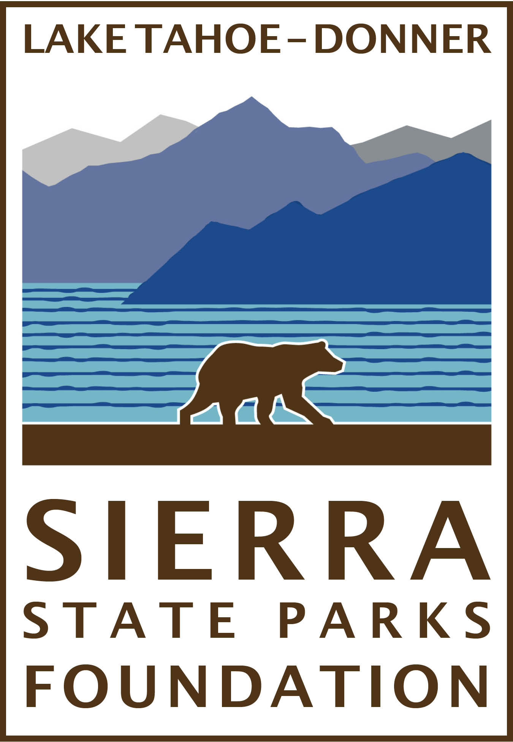 FACT - ARTIFACT - OBSERVATION CARD

People/Group:_____________ Time period: ______________

Description of Fact/Artifact/Observation:

____________________________________________________

_____________________________________________________

_____________________________________________________

_____________________________________________________

Is this a fact, artifact or observation? Circle one of the following:
Fact Artifact Observation

What does this tell me about the time period? Circle one:
- Place
- Family
- Community
- Daily Life
POST LESSON
Purpose: To tie in Sierra State Park to the overall sequence of historical events in the community of Lake Tahoe.

INQUIRY QUESTION:
How is our life different from those who lived in our community in the past and how is it the same?
Lesson Questions: What is our community like? What was community life like in the past? How do communities then and now remember their past?

Sierra State Park State Park as part of Lake Tahoe History:
Part I: Sharing out Facts-Artifacts-Observations of Time Periods & Communities of ____________

Option A: Whole Class Share Out
Prep: Teacher will go through Fact-Artifact Cards and pick out the ones that best reveal about life for each of the different time periods.

- Teacher groups students into pairs or trios.
- Teacher hands out Fact-Artifact Observation Cards to pair/trios.
- Teacher calls on Pairs/Trios to share out Fact-Artifact Cards for each Time Period
- Teacher projects the card for students to copy on their handout “Time Periods & Communities of Lake Tahoe & Sierra State Parks.”

Option B: Matching Fact-Artifact- Observation Cards with Time Periods
Prep: Teacher will go through Fact-Artifact Cards and make group sets of cards with facts for each different time period.

- Teacher makes student groups.
- Teacher hands out Fact-Artifact Observation Card sets to groups.
- Groups Match Fact-Artifact Cards to each Time Period
- Teacher checks each groups matching to make sure it’s correct
- Teacher calls out each time period and asks each student group to share out something for the time period.
- Teacher writes and projects a summary for students to copy on their handout “Time Periods & Communities of Lake Tahoe & Sierra State Parks.”

Part II: Discussion/Writing Assignment - How Things are Different Now (change over time)
Teachers can lead class in discussion or writing assignment to evaluate how things have changed or remained the same over time using the following categories and using photos, artifacts, letters and other evidence to show how communities then and now remember their past:

- Place
- Family
- Community
- Daily Life

TIME PERIODS & COMMUNITIES OF LAKE TAHOE & SIERRA STATE PARKS
FOR TEACHER USE | Pre-, During and Post Visit Lesson  Lake Tahoe Community Then
Time Period | IMAGE ANALYSIS  What was life like then?  (Place, Family, Community, Daily Life) | TOUR AT SIERRA STATE PARK  What was life like then?  (Place, Family, Community, Daily Life)
I. Native Americans:  Washoe | Image  What does this image show about life for the Native Americans? (Place they Lived, Family, Community, Daily Life Activities) | Fact/observation at Sierra State Park  What does this image fact or artifact show about life for the Native Americans? (Place they Lived, Family, Community, Daily Life Activities)
II. Westward Expansion (1844-1857):
Exploration & Settlement
III. Gold Rush & Comstock Lode
(1859-1882)
Mining Boom Enterprises
IV. Gilded Age (1890’s-1920’s):
Hoteliers & Hospitality

Pre-, During and Post Visit Lesson
Lake Tahoe Community Then
Time Period | IMAGE ANALYSIS  What was life like then?  (Place, Family, Community, Daily Life) | TOUR AT SIERRA STATE PARK  What was life like then?  (Place, Family, Community, Daily Life)
V. Industrialization (1860-1920) Technological Advances
VI. Intra-War Years (1920’s-1940’s):
Private Homes & Leisure
VII. Post War Boom
(1940’s-70s):
Destination Tourism, Sport Resorts, Housing Development
VIII. Sierra State Parks
(1880’s-present)

